Algorithms and Data Structures
Exercise 1: Inventory Management System
using System;
using System.Collections.Generic;

class Product
{
public int Id;
public string Name;
public int Quantity;

public Product(int id, string name, int quantity)
{
Id = id;
Name = name;
Quantity = quantity;
}
}

class Program
{
static List<Product> inventory = new List<Product>();

static void AddProduct()
{
inventory.Add(new Product(101, "Laptop", 10));
inventory.Add(new Product(102, "Mouse", 25));
inventory.Add(new Product(103, "Keyboard", 15));
}

static void DisplayProducts()
{
foreach (Product p in inventory)
{
Console.WriteLine("ID: " + p.Id +
", Name: " + p.Name +
", Quantity: " + p.Quantity);
}
}

static void Main()
{
AddProduct();
DisplayProducts();
}
}
Output-
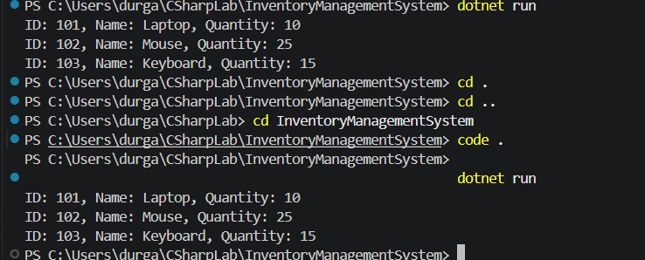

Exercise 2: E-commerce Platform Search Function
using System;
class Product
{
public int Id;
public string Name;
public Product(int id, string name)
{
Id = id;
Name = name;
}
}
class Program
{
static void Main()
{
Product[] products =
{
new Product(101, "Laptop"),
new Product(102, "Mobile"),
new Product(103, "Headphones"),
new Product(104, "Keyboard")
};
string searchItem = "Mobile";
bool found = false;
foreach (Product product in products)
{
if (product.Name == searchItem)
{
Console.WriteLine("Product Found");
Console.WriteLine("ID: " + product.Id);
Console.WriteLine("Name: " + product.Name);
found = true;
break;
}
}

if (!found)
{
Console.WriteLine("Product Not Found");
}
}
}
Output-
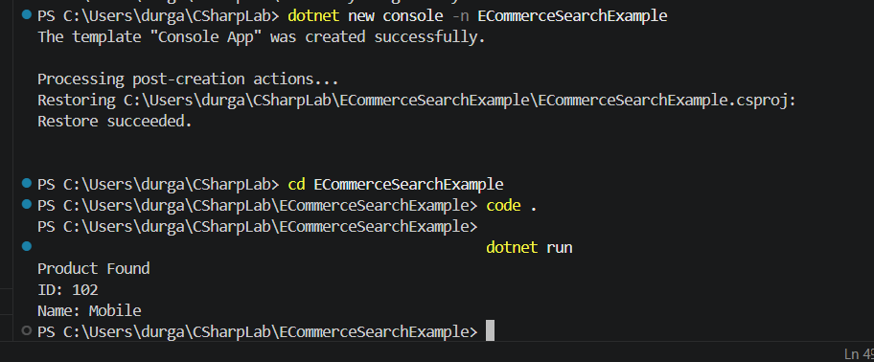
Exercise 3: Sorting Customer Orders
using System;
class Order
{
public int OrderId { get; set; }
public string CustomerName { get; set; }
public double TotalPrice { get; set; }

public Order(int id, string name, double price)
{
OrderId = id;
CustomerName = name;
TotalPrice = price;
}
}

class Program
{
static void BubbleSort(Order[] arr)
{
int n = arr.Length;

for (int i = 0; i < n - 1; i++)
{
for (int j = 0; j < n - i - 1; j++)
{
if (arr[j].TotalPrice > arr[j + 1].TotalPrice)
{
Order temp = arr[j];
arr[j] = arr[j + 1];
arr[j + 1] = temp;
}
}
}
}

static void QuickSort(Order[] arr, int low, int high)
{
if (low < high)
{
int pi = Partition(arr, low, high);

QuickSort(arr, low, pi - 1);
QuickSort(arr, pi + 1, high);
}
}

static int Partition(Order[] arr, int low, int high)
{
double pivot = arr[high].TotalPrice;
int i = low - 1;

for (int j = low; j < high; j++)
{
if (arr[j].TotalPrice < pivot)
{
i++;

Order temp = arr[i];
arr[i] = arr[j];
arr[j] = temp;
}
}

Order temp1 = arr[i + 1];
arr[i + 1] = arr[high];
arr[high] = temp1;

return i + 1;
}

static void PrintOrders(Order[] arr)
{
foreach (var o in arr)
{
Console.WriteLine($"{o.OrderId} | {o.CustomerName} | {o.TotalPrice}");
}

Console.WriteLine();
}

static void Main(string[] args)
{
Order[] orders =
{
new Order(101, "Durga", 5000),
new Order(102, "Priya", 1200),
new Order(103, "Neelima", 8000),
new Order(104, "Kavya", 3000)
};

Order[] bubbleOrders = (Order[])orders.Clone();
Order[] quickOrders = (Order[])orders.Clone();

Console.WriteLine("Before Sorting:");
PrintOrders(orders);

BubbleSort(bubbleOrders);
Console.WriteLine("After Bubble Sort:");
PrintOrders(bubbleOrders);
QuickSort(quickOrders, 0, quickOrders.Length - 1);
Console.WriteLine("After Quick Sort:");
PrintOrders(quickOrders);
}
}
Output-
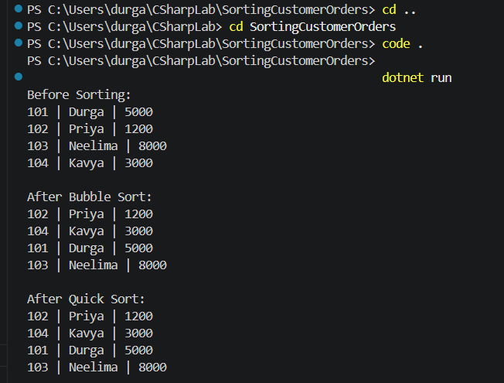
Exercise 4: Employee Management System
using System;

class Employee
{
public int EmployeeId { get; set; }
public string Name { get; set; }
public string Position { get; set; }
public double Salary { get; set; }

public Employee(int id, string name, string position, double salary)
{
EmployeeId = id;
Name = name;
Position = position;
Salary = salary;
}
}

class Program
{
static Employee[] employees = new Employee[10];
static int count = 0;

static void AddEmployee(Employee emp)
{
if (count < employees.Length)
{
employees[count] = emp;
count++;
Console.WriteLine("Employee added successfully");
}
else
{
Console.WriteLine("Array is full");
}
}

static void SearchEmployee(int id)
{
for (int i = 0; i < count; i++)
{
if (employees[i].EmployeeId == id)
{
Console.WriteLine($"Found: {employees[i].Name} | {employees[i].Position} | {employees[i].Salary}");
return;
}
}

Console.WriteLine("Employee not found");
}

static void DisplayEmployees()
{
Console.WriteLine("\nEmployee List:");

for (int i = 0; i < count; i++)
{
Console.WriteLine($"{employees[i].EmployeeId} | {employees[i].Name} | {employees[i].Position} | {employees[i].Salary}");
}
}

static void DeleteEmployee(int id)
{
int index = -1;

for (int i = 0; i < count; i++)
{
if (employees[i].EmployeeId == id)
{
index = i;
break;
}
}

if (index == -1)
{
Console.WriteLine("Employee not found");
return;
}

for (int i = index; i < count - 1; i++)
{
employees[i] = employees[i + 1];
}
count--;
Console.WriteLine("Employee deleted successfully");
}
static void Main(string[] args)
{
AddEmployee(new Employee(101, "Durga", "Manager", 50000));
AddEmployee(new Employee(102, "Priya", "Developer", 40000));
AddEmployee(new Employee(103, "Kavya", "Tester", 30000));
DisplayEmployees();
SearchEmployee(102);
DeleteEmployee(102);
DisplayEmployees();
}
}
Output-
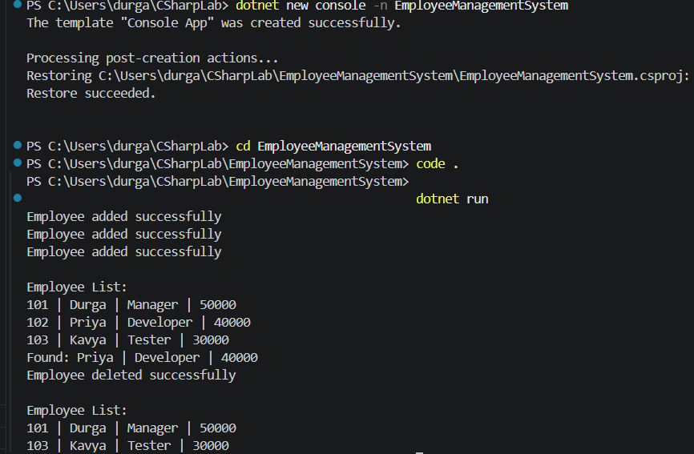
Exercise 5: Task Management System
using System;

class Task
{
public int TaskId { get; set; }
public string TaskName { get; set; }
public string Status { get; set; }

public Task(int id, string name, string status)
{
TaskId = id;
TaskName = name;
Status = status;
}
}

class Program
{
static Task[] tasks = new Task[10];
static int count = 0;

static void AddTask(Task task)
{
if (count < tasks.Length)
{
tasks[count] = task;
count++;
Console.WriteLine("Task added successfully");
}
else
{
Console.WriteLine("Task list is full");
}
}

static void SearchTask(int id)
{
for (int i = 0; i < count; i++)
{
if (tasks[i].TaskId == id)
{
Console.WriteLine($"Found: {tasks[i].TaskName} | {tasks[i].Status}");
return;
}
}

Console.WriteLine("Task not found");
}

static void DisplayTasks()
{
Console.WriteLine("\nTask List:");

for (int i = 0; i < count; i++)
{
Console.WriteLine($"{tasks[i].TaskId} | {tasks[i].TaskName} | {tasks[i].Status}");
}
}

static void DeleteTask(int id)
{
int index = -1;

for (int i = 0; i < count; i++)
{
if (tasks[i].TaskId == id)
{
index = i;
break;
}
}

if (index == -1)
{
Console.WriteLine("Task not found");
return;
}

for (int i = index; i < count - 1; i++)
{
tasks[i] = tasks[i + 1];
}

count--;

Console.WriteLine("Task deleted successfully");
}

static void Main(string[] args)
{
AddTask(new Task(101, "Design UI", "Completed"));
AddTask(new Task(102, "Develop Backend", "In Progress"));
AddTask(new Task(103, "Testing", "Pending"));

DisplayTasks();

SearchTask(102);

DeleteTask(102);

DisplayTasks();
}
}
Output-
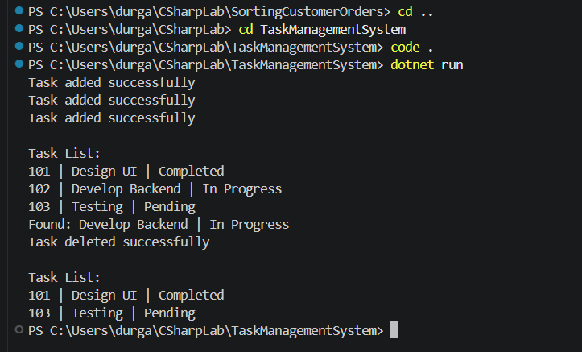
Exercise 6: Library Management System
using System;

class Book
{
public int BookId { get; set; }
public string Title { get; set; }
public string Author { get; set; }

public Book(int id, string title, string author)
{
BookId = id;
Title = title;
Author = author;
}
}

class Program
{
static int LinearSearch(Book[] books, string title)
{
for (int i = 0; i < books.Length; i++)
{
if (books[i].Title.Equals(title, StringComparison.OrdinalIgnoreCase))
return i;
}
return -1;
}

static int BinarySearch(Book[] books, string title)
{
int left = 0;
int right = books.Length - 1;

while (left <= right)
{
int mid = (left + right) / 2;

int compare = string.Compare(
books[mid].Title,
title,
StringComparison.OrdinalIgnoreCase
);

if (compare == 0)
return mid;
else if (compare < 0)
left = mid + 1;
else
right = mid - 1;
}

return -1;
}

static void Display(Book[] books)
{
foreach (var b in books)
{
Console.WriteLine($"{b.BookId} | {b.Title} | {b.Author}");
}

Console.WriteLine();
}

static void Main(string[] args)
{
Book[] books =
{
new Book(101, "Python Programming", "Durga"),
new Book(102, "Data Structures", "Priya"),
new Book(103, "Operating Systems", "Kavya"),
new Book(104, "Computer Networks", "Neelima"),
new Book(105, "Database Management", "Hema")
};

Console.WriteLine("Book List:");
Display(books);

int result1 = LinearSearch(books, "Computer Networks");

if (result1 != -1)
Console.WriteLine("Linear Search Found: " + books[result1].Title);
else
Console.WriteLine("Not Found");

Array.Sort(books, (a, b) => a.Title.CompareTo(b.Title));

int result2 = BinarySearch(books, "Computer Networks");

if (result2 != -1)
Console.WriteLine("Binary Search Found: " + books[result2].Title);
else
Console.WriteLine("Not Found");
}
}
Output-
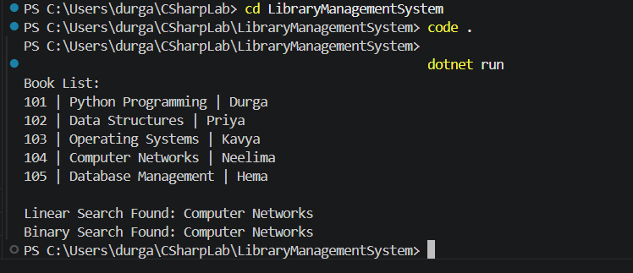
Exercise 7: Financial Forecasting
using System;

class Program
{
static double Forecast(double currentValue, double growthRate, int years)
{
if (years == 0)
return currentValue;

return Forecast(currentValue * (1 + growthRate), growthRate, years - 1);
}

static void Main(string[] args)
{
double currentRevenue = 100000;
double growthRate = 0.10;
int years = 5;

Console.WriteLine("Current Revenue: " + currentRevenue);
Console.WriteLine("Growth Rate: " + (growthRate * 100) + "%");
Console.WriteLine("Years: " + years);
double futureRevenue = Forecast(currentRevenue, growthRate, years);
Console.WriteLine();
Console.WriteLine("Predicted Revenue after " + years + " years: " + futureRevenue);
}
}
Output-
